PROJECT DOCUMENTATION
MNIST Handwritten Digit Classification Using a Neural Network
Python • TensorFlow/Keras • MNIST • OpenCV

1. Abstract
This project develops a handwritten digit classification system using the MNIST dataset and a feed-forward neural network implemented with TensorFlow/Keras. The dataset contains 60,000 training images and 10,000 test images, each represented as a 28 × 28 grayscale image. Pixel values are normalized, the images are flattened, and the resulting vectors are passed through two hidden Dense layers before producing scores for the ten digit classes.
According to the supplied notebook, the model reaches 99.16% training accuracy after 10 epochs and 97.04% test accuracy. The notebook also demonstrates an end-to-end predictive system using a supplied image file; the provided 3-digit.PNG sample is classified as digit 3.

2. Problem Statement
Handwritten digits have large variations in writing style, stroke thickness, shape, and positioning. The objective of this project is to train a neural network that can learn patterns from labeled handwritten digit images and predict which digit (0–9) appears in a new image.

3. Objectives
- Load and inspect the MNIST handwritten digit dataset.
- Understand image dimensions, labels, and class values.
- Normalize image pixel values for neural-network training.
- Build and train a neural network using Keras.
- Measure model performance on unseen test data.
- Use a confusion matrix to inspect classification behavior.
- Create a predictive system for an external digit image.

4. Dataset Description
Property | Value
Dataset | MNIST
Training samples | 60,000
Testing samples | 10,000
Image dimensions | 28 × 28 pixels
Image type | Grayscale / 1 channel
Classes | 10 (0–9)
Training array | (60000, 28, 28)
Testing array | (10000, 28, 28)

5. System Workflow
The implementation follows a sequential machine-learning workflow:
- Import dependencies.
- Load MNIST using keras.datasets.mnist.
- Inspect shapes, sample images, and unique labels.
- Normalize training and test pixels by dividing by 255.
- Construct the Keras Sequential neural network.
- Compile with Adam, sparse categorical crossentropy, and accuracy.
- Train for 10 epochs.
- Evaluate the trained model on the test set.
- Generate class scores and convert them to predicted labels with argmax.
- Create and inspect a confusion matrix.
- Read, grayscale, resize, normalize, reshape, and classify an external image.

6. Model Architecture
Layer | Configuration | Purpose
Input | 28 × 28 | Receives the grayscale digit image
Flatten | 28 × 28 → 784 | Converts the image matrix into a vector
Dense 1 | 50 units, ReLU | Learns nonlinear digit patterns
Dense 2 | 50 units, ReLU | Learns higher-level combinations of features
Output | 10 units, sigmoid | Produces scores for digit classes 0–9
The notebook compiles this model using the Adam optimizer, sparse categorical crossentropy loss, and accuracy as the evaluation metric. The architecture above is documented as implemented in the supplied notebook.

7. Data Preprocessing
- MNIST images already share a common 28 × 28 size.
- The training and test images are scaled from their original 0–255 pixel range to approximately 0–1.
- For an external image, OpenCV reads the file, converts it to grayscale, and resizes it to 28 × 28.
- The resized image is normalized by dividing by 255 and reshaped to (1, 28, 28) for model prediction.

8. Training Configuration
Parameter | Notebook setting
Optimizer | Adam
Loss function | Sparse categorical crossentropy
Metric | Accuracy
Epochs | 10
Hidden layers | 2 Dense layers
Hidden units | 50 + 50
Hidden activation | ReLU
Output units | 10
Output activation | Sigmoid

9. Training Results
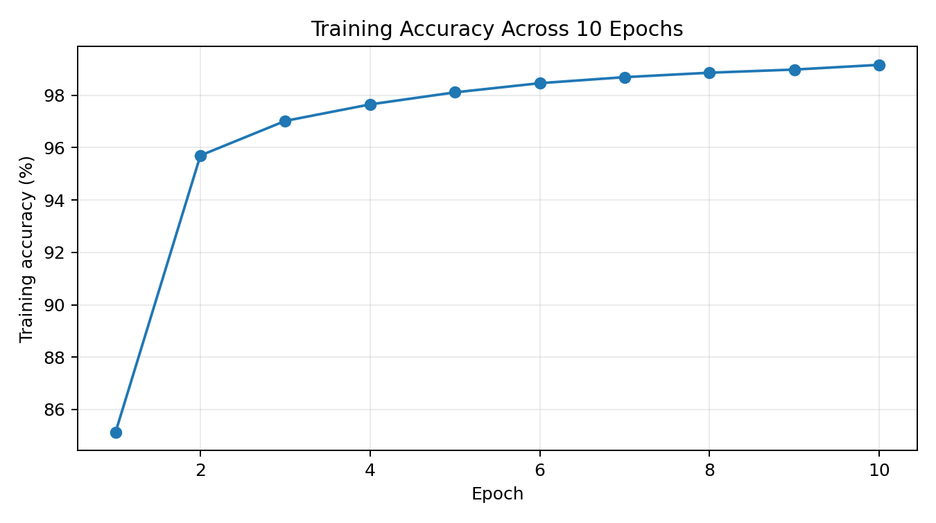
Training accuracy rises steadily across the ten recorded epochs, reaching 99.16% at epoch 10.
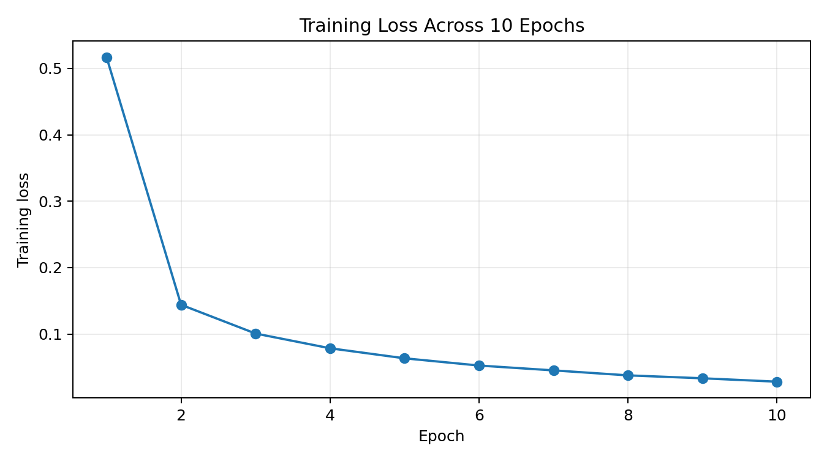
Training loss decreases from 0.5167 in epoch 1 to 0.0282 in epoch 10.

10. Test Evaluation
The notebook evaluates the model with model.evaluate(X_test, Y_test). The recorded test accuracy is 0.9703999757766724, approximately 97.04%. The notebook's accompanying markdown reports this as 97.1%.

11. Confusion Matrix
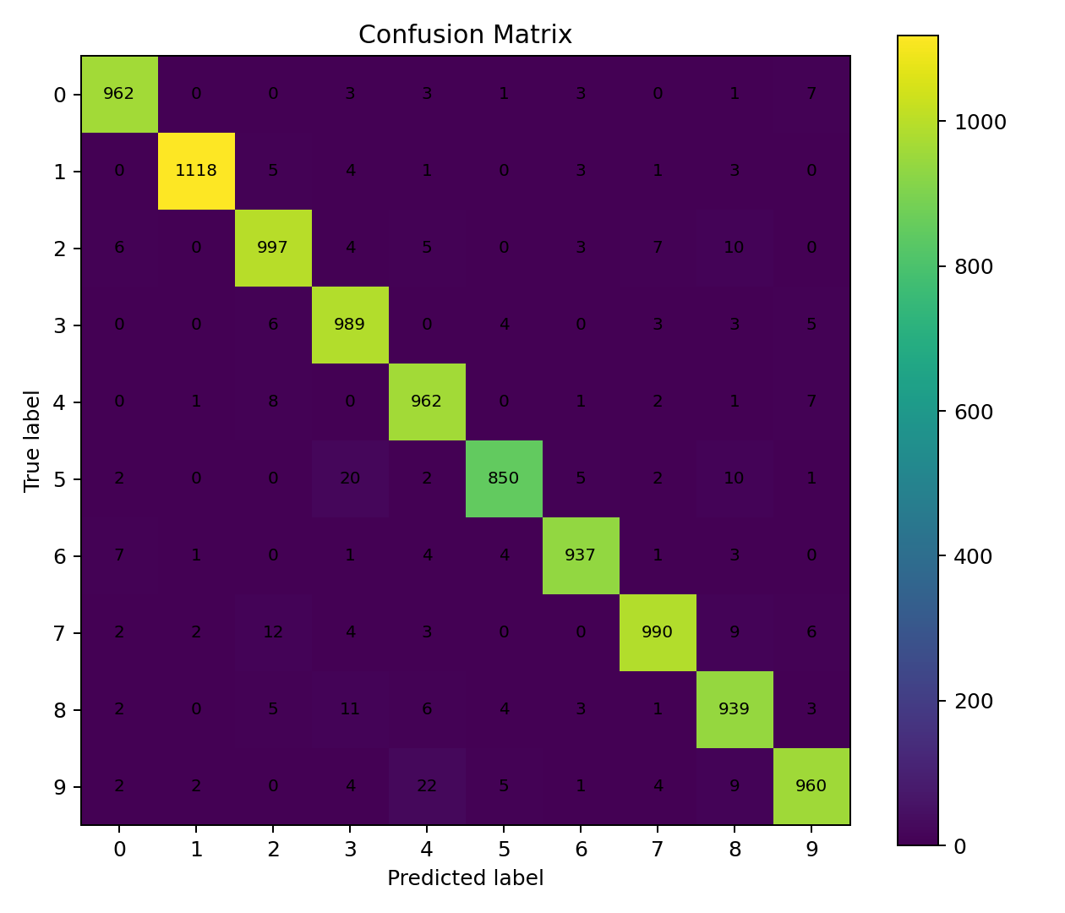
The confusion matrix compares true labels against predicted labels for the ten digit classes. Most observations fall on the diagonal, indicating correct classifications. Some off-diagonal errors are visible, including confusion involving digits such as 3, 5, 8, and 9.

12. Predictive System
The predictive-system section allows an image path to be supplied interactively. The image is read with OpenCV, converted to grayscale, resized to 28 × 28, normalized, reshaped, and passed to the trained network. The predicted class is obtained with np.argmax.

Figure: supplied 3-digit.PNG sample. The notebook's predictive system recognizes it as digit 3.

13. Key Code Flow
# Normalize MNIST
X_train = X_train / 255
X_test = X_test / 255
# Build model
model = keras.Sequential([
keras.layers.Flatten(input_shape=(28, 28)),
keras.layers.Dense(50, activation='relu'),
keras.layers.Dense(50, activation='relu'),
keras.layers.Dense(10, activation='sigmoid')
])
# Compile
model.compile(
optimizer='adam',
loss='sparse_categorical_crossentropy',
metrics=['accuracy']
)
# Train
model.fit(X_train, Y_train, epochs=10)

14. Tools and Technologies
- Python — programming language.
- NumPy — numerical arrays and reshaping.
- Matplotlib — image and training visualizations.
- Seaborn — confusion-matrix heatmap.
- OpenCV — external-image reading, grayscale conversion, and resizing.
- PIL — image handling imported in the notebook.
- TensorFlow/Keras — dataset access, neural-network construction, training, and inference.
- Google Colab utilities — notebook uses cv2_imshow and Google Drive mounting.

15. Limitations
- The model is trained specifically on MNIST-style handwritten digits.
- External images can differ from MNIST in background, centering, contrast, stroke width, or scale.
- The external-image pipeline performs basic preprocessing only.
- The notebook is oriented toward Google Colab because it uses Colab-specific paths and utilities.
- The model is retrained when the notebook is executed from the beginning unless it is explicitly saved and reloaded.

16. Future Enhancements
- Use a convolutional neural network (CNN) for stronger spatial feature extraction.
- Add image centering, thresholding, inversion checks, and foreground cropping.
- Save the trained model and provide a separate inference script.
- Build a web UI for drag-and-drop digit prediction.
- Add precision, recall, F1-score, and per-class evaluation.
- Deploy the model through an API or lightweight web service.

17. Conclusion
The project demonstrates a complete introductory deep-learning workflow for handwritten digit classification: dataset loading, inspection, preprocessing, neural-network training, evaluation, error analysis through a confusion matrix, and inference on a new image. The supplied notebook achieves approximately 97.04% test accuracy and correctly classifies the supplied sample image as 3.

18. Source Notebook
This documentation is based on the supplied file: MNIST_Digit_classification_using_Neural_Networks.ipynb. Project-specific values and implementation details have been kept aligned with that notebook.

